We are seeking people who have home improvement skills. It is our desire to make improvements to God’s house. There are some projects that need to be done and we need some help. If you are interested in helping. Please plan on attending a meeting on April 15th after service.

Taxes are due – Help needed and appreciated!

April 8th – 1-3 PM Celebration Meal

Invite neighbors, friends and all are welcome. More details to follow.

Wednesday prayer night

Every Week from 6-7PM

Deeper Learning every Sunday from 8:45-9:45AM

Please support our Youth Group fundraiser by donating items to the church for an auction and dinner.

Please see Darlene, Vandy, Christine, Greg or Nate. More detail to come.

Ladies Meeting this next week at Crosspointe Community Church:

Thursday – 6 PM

Friday – Noon – 2 PM



**Sermon Title**

**THERE IS POWER IN THE DARKNESS**

**JOHN 1:4-5**

Welcome to CrossPointe Community Church!

What a joy it is to have you with us today! No matter where you are at on your spiritual journey, CrossPointe welcomes you!

Our mission at CrossPointe is "Connecting People to God and to Each Other". We are a church committed to reaching UPWARD THROUGH WORSHIP, INWARD THROUGH DISCIPLESHIP, and OUTWARD THROUGH EVANGELISM.

It is our prayer that while you are here with us, you feel a connection to God and a connection to the people who attend our church.

We are excited about what the Lord is doing among us here and it is our hope that you will enjoy today's service!

--Pastor Isaiah and Leta Johnson

**CROSSPOINTE VALUES**

Youth Group news –

Today - Fundraiser Car wash and bake sales – Everyone please come out

Wednesday 30th Youth Café and Service

Today’s Date: ___________________________

Name _________________________________

Single Married

Birthday_______________________________

Spouse________________________________

Children:

___________________Age__________

___________________Age__________

___________________Age__________

Email: ________________________________

Address: ______________________________

City: __________________________________

State: ______________Zip: _______________

Cell Phone: ____________________________

Your Age Group: 0-12 13-19

20-30 40-50 60 and over

How did you hear about CrossPointe?

Website Facebook Mailer

Friend Other_____________

If you are a Guest, we have a Gift for you.

Please bring this card by our Guest Services.

1St Time Guest 3rd Time Guest

2nd Time Guest Regular Attender

Community Block Party

August 26th

10- 12 setup 12-4 event

We will have a bounce house and a 45ft obstacle course inflatable

Air Brush face painter, Volley Ball,

Ga GA ball, Four square, Basketball, Bump competition, Calk art,

Water balloon toss, Yard Twister, Carnival games, Cubby Bunny game, Free Burgers and Hot dogs and Drinks, Music and more.

Block Party Challenge

We are challenging everyone to invite

5 Families and Friends

To bring them to the Block Party

Take flyers and invite everyone

We are starting to collect candy

For the Kids for the Easter candy hunt.

Please bring your candy

to Kim or Christine Robinson

Ladies Craft Day

April 22nd 10-4

Come work on any items you need to finish or just get started. Bring a snack to share. See Kim for details

Spring Bazaar May 6th 9-4

Table rental is free!

If you want to sell crafts, food, handmade items, or just promote your business. Contact Kim

Men’s Conference

May 19th and 20th

Pasco, WA

Mark your calendars

More info to follow

**Kingdom Builders**

March 10th@7pm

March 11th @12pm

March 12th@10:30am

Speakers

Wanda Gladney, Pastor Isaiah & Leta

Bo Salisbury, Tim & Angela Rambo

Men’s Bible Study and Breakfast

Saturday March 11th

9-11 am Downstairs

Connect

May Income $5917.00 June Income $4534.00

Expense $6937.00 Expense $4,954.00

**Sermon**

**Announcements**



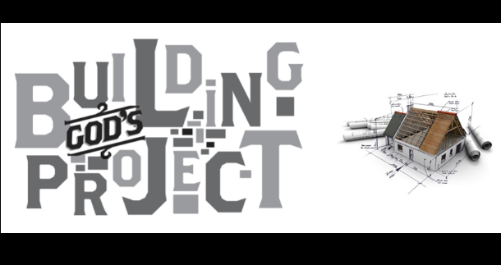



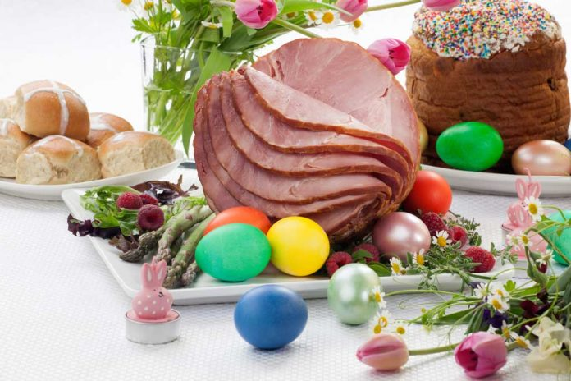





Touch!

Woman Bible Study

Thursday March 3

6:30-8:00pm

**Presence of God Mission**

**Authentic Community Creativity**

**Truth Personal Growth**

Sermon

**Walking Worthy of the Calling**

**Ephesians 4:1-3**





Isaiah & Leta Johnson

Lead Pastors

Tom Boon  
Worship Leader  
  
Nate Robinson  
Youth Pastor and Outreach  
  
Carolyn Tolliver  
Assistant to the Pastor  
  
Paul and Media Davis  
Intercessory Prayer Leaders and Deeper Learning Class  
  
Christine Robinson  
Children's Church Leader  
  
Grace Vasquez  
Nursery Leader  
  
Charlie Mugler

Media- General Maintenance

https://www.facebook.com/CrossPointe-Community-Church-135937796432205/?fref=ts



What’s Next?

Start

I dedicate my life to Jesus for the first time.

I re-dedicate my life to Jesus.

Next Step

I’m interested in getting Baptized.

I would like to become a member.

I would like to talk to Pastor.

Get Involved

I want to become a member

I want to volunteer for a ministry:

Children’s Youth Greeter Prayer Team

Worship Team Guest Service Men’s

Women’s Sound Tech Nursery

**Prayer Request / Questions:**

_______________________________________________________________________________________________________________________________________________________________________________________________________________________________________________________________________________________________________________________________________________________________

Confidential Please Add to Prayer Chain



**Community Church**

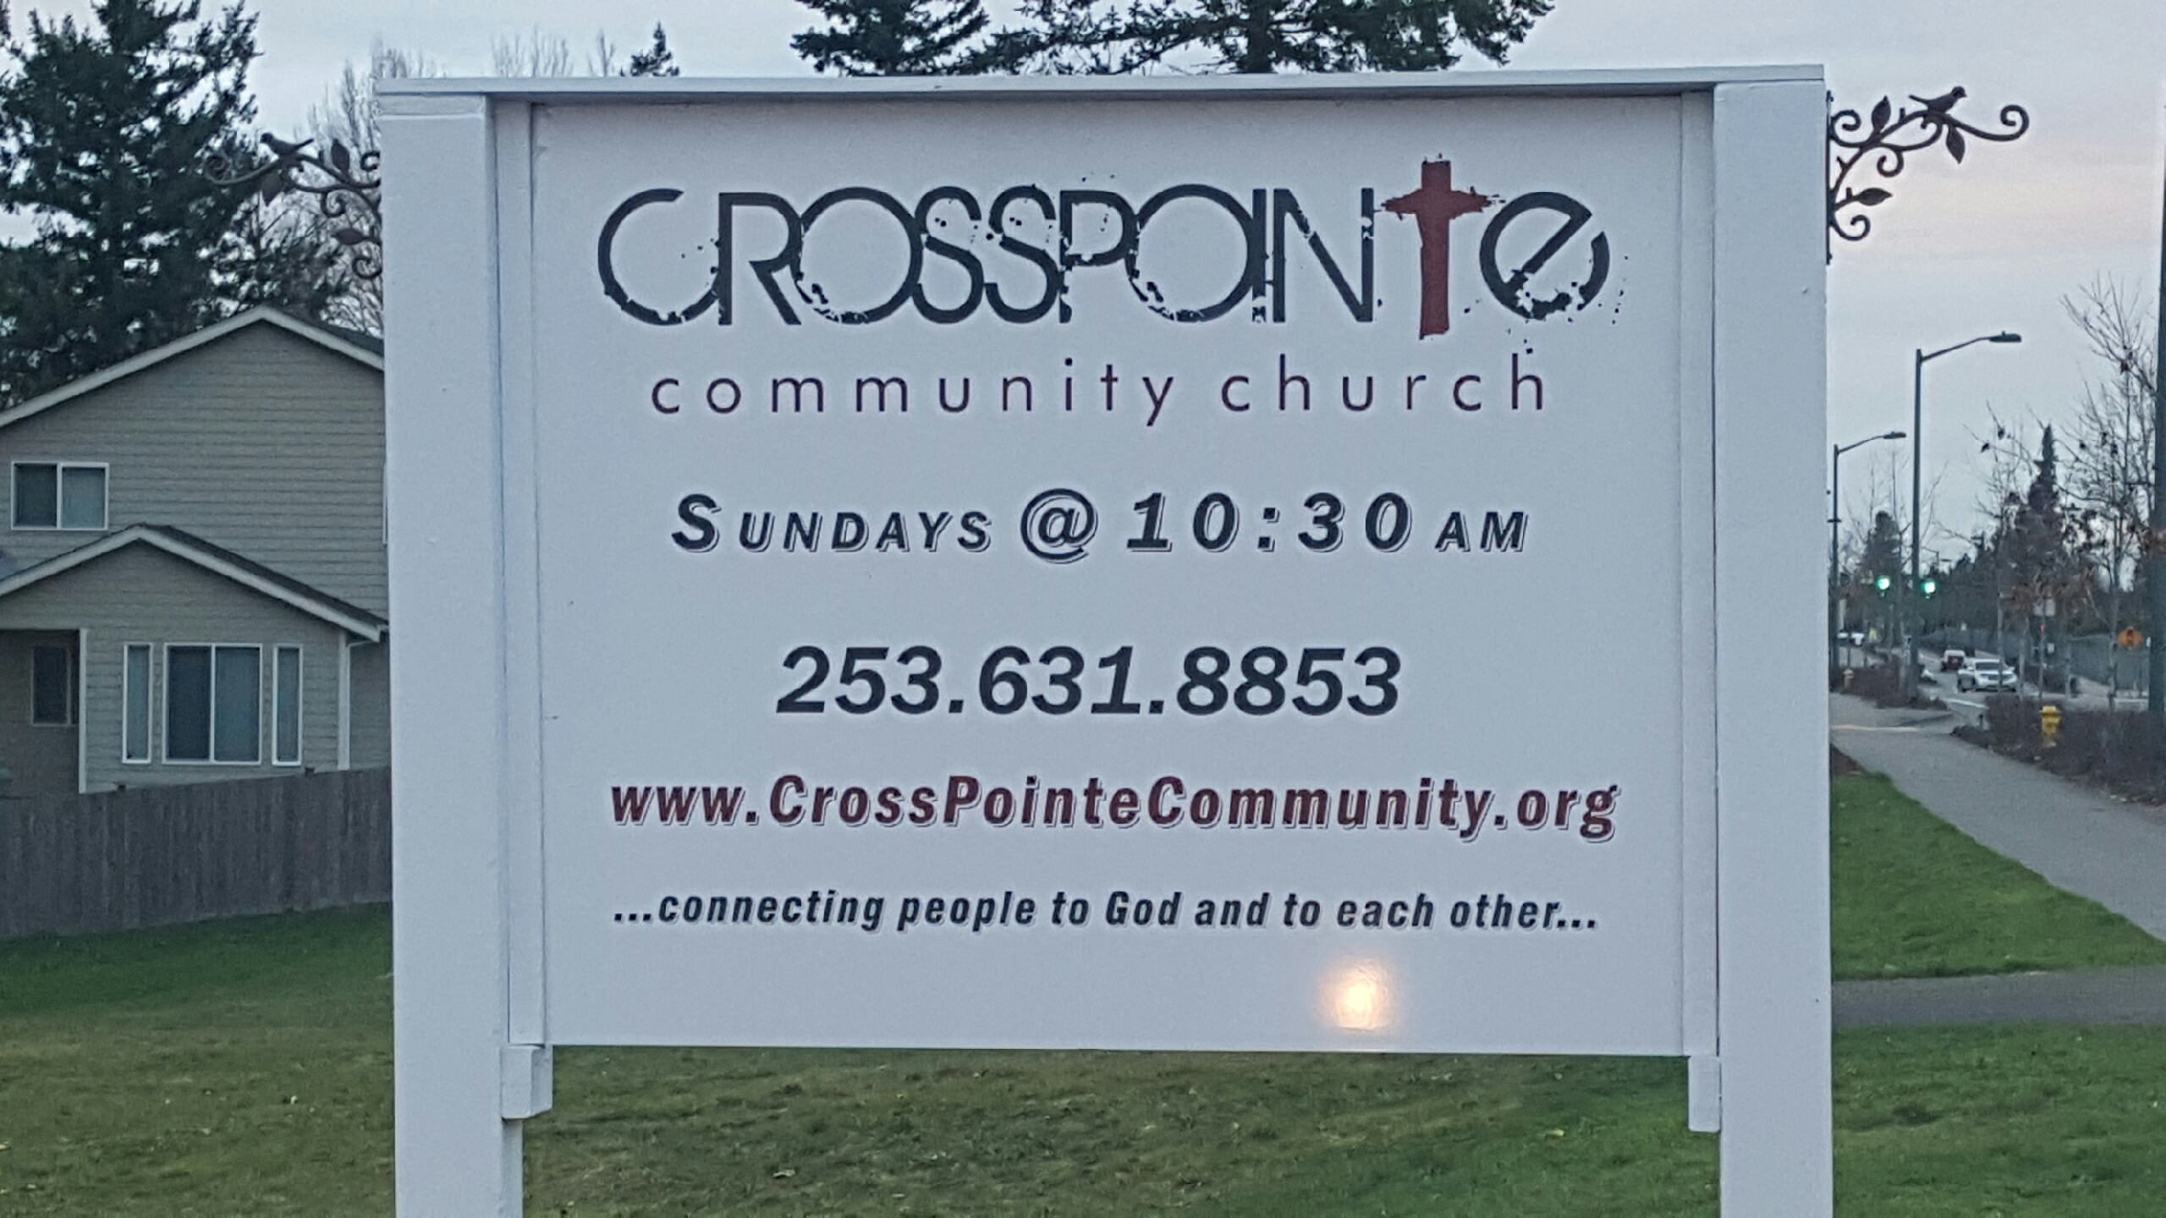

Join us for service every Sunday at 10:30am

April 1st ,2018

**26223 164th Ave. SE**

**Covington, WA 98042**

**253-631-8853**

Connecting People to God and

To Each Other

Because All People Matter

To God